JIM PATCH

REMINSCENCES OF
THE LONG RANGE DESERT GROUP

- 1943–1945

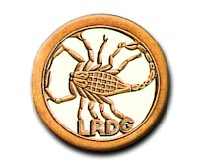

"NON VI SED ARTE" -- "NOT BY STRENGTH, BY GUILE"

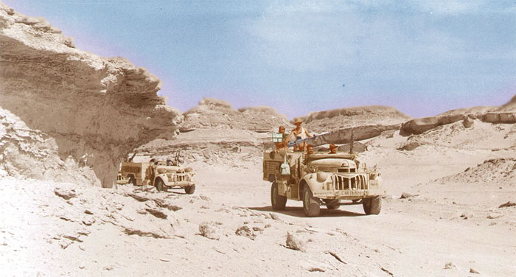

The desert campaign was concluded in May 1943 with the surrender of Axis forces in Tunesia, and Jim and his colleagues in the LRDG prepared for a very different role.

Jim's group was ordered to learn Greek; an order which he had little difficulty in complying with: "They sent a teacher from Alexandria - a very attractive young lady!"

He learned Greek through the spring and summer of 1943, and his unit spent time training in the Lebanon mountains. The LRDG had changed roles and operations were now planned in the eastern Mediterranean, carrying out missions in the Greek islands and the Balkans. The training was aimed towards landing on the coast of the various countries around the Adriatic, including Albania, and what was then Yugoslavia, in order to assist partisan groups operating in those countries. The work was arduous and included skiing tuition and parachute training.

The men were medically assessed; and Jim nearly failed when he was tested for colour blindness. The test consisted of an army medic pointing at the coloured cover of a magazine and asking the man being tested what colours he was indicating. Jim got it completely wrong; so it seemed he was colour blind. There was a simple solution though - the medic told him he would have to follow the man in front!

Training continued in Palestine, where the course included jumping off moving vehicles. Jim's first actual parachute jump was to take place the next morning so the trainees were given the day off and went into Tel Aviv. When they got back to camp, they found the place in a flap. It seemed Italy had opted out of the war and so all territories hitherto occupied by Italian forces had now to be reoccupied by the Allies.

Jim's unit was sent to Haifa where it was embarked on a Greek warship and shipped to the Dodecanese Islands, landing at Kalymnos.

"We were greeted by a starving population. The Italians had been particularly strict during their occupation. The Germans had begun to occupy the Greek islands, recognising them as strategically important for an Allied attack on the soft underbelly of Europe. They first attacked Kos, which had the only airfield amongst the islands. The defending Hurricane squadron, South African, was shot down one by one and Kos was completely taken over. Then the Germans started bombing the other islands."

Jim's unit was shipped to Leros and landed there. They were attacked by Stukas.

"It was a bad time. A friend of mine, "Pusher" Whealdon, was a brave man and had a proper go at the Stukas with a Bren gun. The rest of us fired at them with rifles from behind a low wall. Pusher was on the quay with the Bren shooting at them. He had no cover and was hit. He was picked up by one of our jeeps, coughing up his lungs. There were bodies everywhere."

Jim 's unit was deployed around the islands. He and thirty others were ordered to Levita, one of the small islands.

"It was about a mile long. It was said to have been taken over by escaped German PoW's. But when we landed, we found it full of Germans. I found myself in open ground without cover confronted by a German machine gun and was captured, and sent with some others by flying boat to Athens. We landed at Piraeus, and were marched to an old Italian barracks. We were placed in the officers' quarters. The guards were Germany's last hope - peasants from the Black Forest whose rifles were as tall as them. We all took the mickey out of them, the poor, pathetic characters. We sang rude American songs at them and they loved it!"

There was little food at the barracks. After a few days, Jim and his friends were marched to a marshalling yard and entrained in two cattle trucks. There was nothing inside except a single bucket for the use of all the men in the truck.

"There was an opening in each of the four corners, covered with barbed wire. I and my friend Ron Hill were well equipped for escaping. Being Special Forces I had a small hacksaw covered in hard rubber sewn into the flies of my uniform trousers, a compass sewn into the collar of my battledress jacket, and a silk map sewn into my beret. The progress of the train was slow. I spent five days cutting through the barbed wire in one of the corners, around three sides so I could open it like a window."

They travelled north through Greece then crossed the border into Yugoslavian Macedonia. They followed their progress on the silk map.

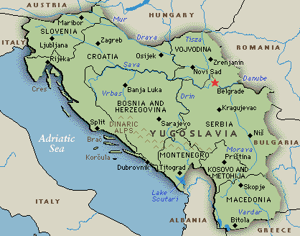

“Escape was only possible at night”, says Jim. “Guards were watching from an open point on the wagon in front of the one on which we were held. The train travelled only short distances at night. An opportunity occurred just north of the town of Veles. The train was going at about twenty five miles per hour.

I lifted the wire, got out and hung on waiting for Ron's boots to appear. The train went through a tunnel and at the far end I dropped off. Our parachute training paid off - I dropped onto gravel but didn't hurt myself. Then I squatted by the rails - the train's wheels were just inches from me - and then the red light at the end of the train passed by."

They had been prisoners for thirteen days. It came to Jim that he was now alone in the middle of occupied Europe. He walked up the track without much hope, looking for his friend.

"Then I found him! He was hiding behind a telegraph pole. He'd twisted a leg muscle and gashed his leg badly on the barbed wire when he got out of the truck."

Jim assessed their position.

"It was November, it was raining, and it was jolly cold. We only had our uniform battledress, our packs and a small blanket each that the Italians had given us. We rolled up the blankets and tied them onto our packs. We had a Red Cross parcel between us, so at least we had a little food. Ron's blanket had fallen under the train wheels and when he unrolled it it had a row of big holes.

"I got my compass out. I thought the only thing to be done was to make for the Adriatic and when we got there, find a boat and get to Italy where the fighting was going on. This meant walking right across Albania.”

They set out, heading south of west. They were at the bottom of a deep ravine, by a steep bank leading back to the train tunnel. They climbed up the ravine but it quickly became clear that Ron was suffering badly with his twisted leg muscle and the gash was bleeding heavily.

"I had a field dressing in my pack, so dressed the wound. Ron was a tough little bloke."

Together they marched on in the rain, on that same compass bearing, south by west. They walked right through that night, and rested up during the day. The Red Cross parcels yielded up some matches, so they were able to get a fire going and try to dry out.

Over the next five days they marched by night and hid up by day. They saw no-one. They stuck to that same compass bearing, traversing steep hills and rough country. They lit fires during daylight and managed to get some warmth and dry out.

On the fifth night, they were on a rocky hill, taking it in turns to use the compass. It was Jim's turn and he was leading the way. At one point he turned around: no Ron. He retraced his steps and found him sitting by a rock.

"He said he'd had it and couldn't go on. It was pouring with rain and sleet, and blowing a gale. I looked for shelter and found a small space under an overhanging rock. I installed Ron there and looked around for somewhere for me. I found a place but it wasn't good. I fell asleep and when I woke up I couldn't move. I tried to get some movement in my body, and when I did I got back to Ron. He was OK - his shelter was just about sufficient."

Jim got Ron to his feet and they struggled on following the same compass bearing. But it was time to look for some human help.

They found a primitive village on a river, with villagers collecting water in containers such as saucepans.

"We filled up our water bottles" says Jim, "and made our way towards the centre of the village. Then we saw a man waving his arms and making it pretty clear we weren't welcome. Ron saw some soldiers in a house. So we turned back and made for the hills again. We followed the river, which flowed roughly in the direction we wanted. We found an isolated hut which was occupied by two men, and they didn't welcome us - just pointed up the hill. We followed their directions for a bit but then returned to the hut. This time they seemed to have changed their minds and invited us in.”

The hut was built of wattle and daub, with a thatched roof and an earthen floor, no furniture except a couple of three-legged stools cut from pine trees with branches growing at right angles for legs. There was a fire in the middle of the floor, and the smoke just percolated through the thatch. A wall divided the hut into two rooms, cattle on one side, people on the other. It was the most primitive habitation you could imagine.

"There was a cooking pot on the fire, and they gave us some food called kachamak. To make that, you boil water and heap double handfuls of maize flour in it until you have a pyramid. Then you stir it up with a stick. What you have then is a kind of lumpy, half-dry, porridge."

Their stomachs lined with this luxurious repast, Jim and Ron were invited to lie down by the fire to get some sleep.

Some time later, they were woken by someone else - a man with a rifle. He demanded their documents, so Jim and Ron handed over their Army paybooks. The man produced a Bulgarian banknote; printed by Thomas de la Rue of Angleterre. The man was clearly hoping to find the word Angleterre in the pay books. They told him they were British and escaped prisoners as best they could by sign language and he seemed to understand.

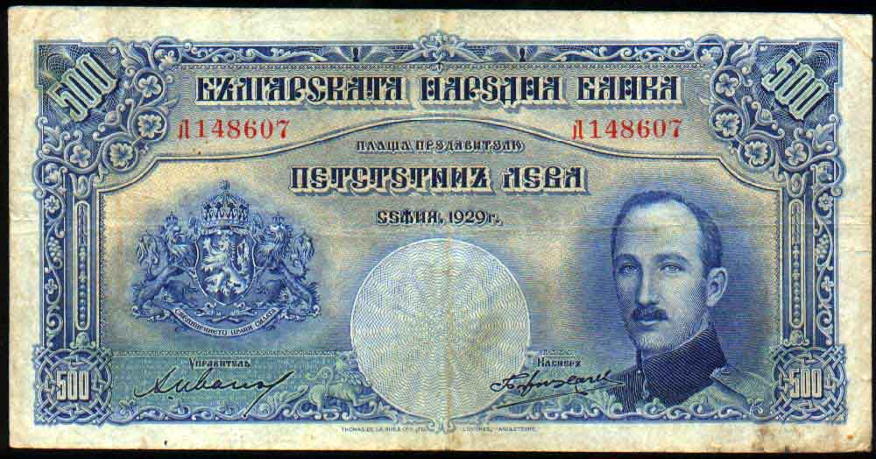

Thomas de la Rue

Their bona fides apparently established, they were escorted by the armed man across the river and were introduced to an armed group. They had found the Chetniks, who mostly comprised remnants of the exiled Yugoslavian King Peter's army who initially had fiercely resisted the German invasion but later had taken their arms to follow a life of resistance in the woods, operating in small bands.

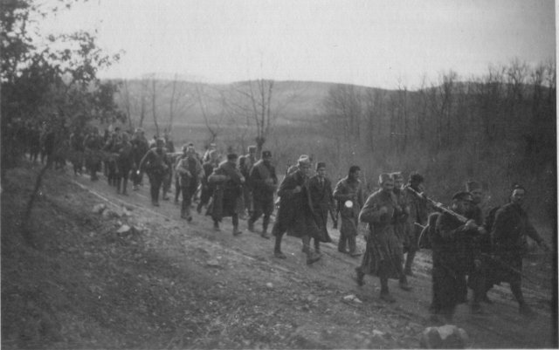
Chetnik irregulars on the march

So Jim and Ron joined the Chetniks and spent the next nine months of their lives with this army. In these, the final years of the war, the Chetniks were involved in operations against Tito's Partisans who were communists. The internal politics of Yugoslavia were complex and continually shifting, and the fighting savage; but latterly the Allies favoured the Partisans, albeit that supplies had been provided to the Chetniks in the early stages of the war, who in fact rescued and sheltered many Allied military personnel from the occupying enemy. Ron and Jim’s band of Chetniks were sustained by local villagers who drove out the occasional sheep or goat and once a bullock to be slaughtered.

"I can still remember how they slaughtered the bullock - he was tipped up and his throat slit. I remember the animal breathing through the gash in his throat."

Macedonia was occupied by Bulgaria whose government had joined the war on the German side. Their soldiers were evacuating all the small villages and concentrating the inhabitants into larger centres. The Chetnik group had to move from place to place to avoid a major clash with the Bulgars.

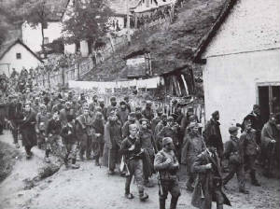
Chetnik column passing through a village

They lived very close to nature. At this time it was snowing heavily, and they were obliged to hide from time to time. They retired to the crater of a remote extinct volcano, where there was a meter of snow on the ground. They kept warm by lighting a fire on the surface; as it melted the snow, the hole got larger and eventually several men could crowd in for shelter. Most of the time they were unable to stay in the villages so lived in the open, building shelters of branches and turf. It was possible to build a fire in these shelters – known locally as kolibas.

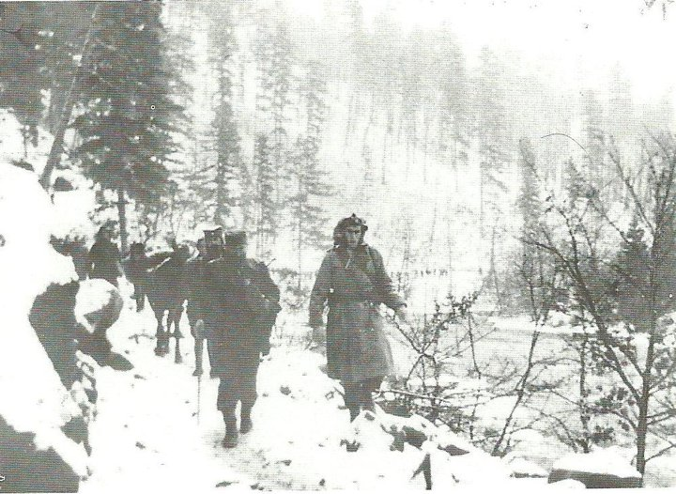
Winter conditions

After nine months, two envoys from the Partisans appeared and a peaceful merger of the two forces was arranged by which the Chetniks, while remaining loyal to King Peter, accepted Tito as their General and became part of his army.

Soon after, Ron and Jim met a British officer and his sergeant radio operator who had been parachuted in to arrange supplies to be dropped to the Partisans. After establishing their identity the officer accepted Ron and Jim as members of his mission. An airfield was set up and planes began to land. Ron was able to speak to the pilot of one of them and handed him a letter to his and Jim’s parents. Thus ended nine months on the “missing” list.

Macedonia having by then been liberated, Ron and Jim were soon flown out and back to Blighty.

“Ron and I were looked after very well by the Chetniks”, says Jim, “and we were glad to have lived amongst them as allies. Our particular friend was Colonel Stojan Markovic, who spoke some English. I learnt the Serbian language by listening to these ex-soldiers of the Royal Yugoslavian army.”

Jim was demobbed in June 1946, and rejoined the GPO in as an officer of the Investigation Branch from 1947 to 1980, detecting crime within and against the Post Office.

