Two serious threats to our trees
– one old, one new

Recent reports in the press and other publications are highlighting the spread of diseases to both our horse chestnut and sweet chestnut trees.

The latest, and most aggressive pest, reckoned to be the most dangerous to the survival of sweet chestnuts is the Oriental chestnut gall wasp (Dryocosmus kuriphilus). This little monster is a recent arrival to UK, being first recorded in the South East last year, since when it has now been found in Farningham woods on Kent, some parkland trees in south London and evidence of it spreading northwards.

The wasp, however, only attacks sweet chestnuts, not the horse chestnut. What it does is weaken the tree’s natural defences and make it vulnerable to attack from a variety of fungi and other insects.

The Forestry Commission advises anyone who has contact with these trees should exercise biosecurity by not removing any materials from the area, and if working, to clean clothes, tool, machinery and vehicles before moving to another area.

I you want more information go to www.forestry.gov.uk/gallwasp

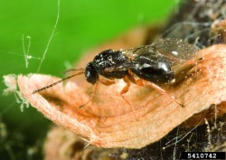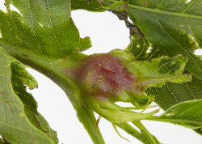

The Oriental chestnut gall wasp The gall in its early stage.

The other pest making itself a very big nuisance is the leaf miner moth (Cameraria ohridella) that’s been around since 2002 when it arrived with a consignment of wood products from Greece. This is in fact only one of a family of leaf miners that attack a wide range of plants. If you have a leaf with signs that some grub has been munching a twisted path in the leaf, it’s more than likely to be a variety of the pest.

The effect of this otherwise insignificant moth is very significant as some authorities believe that there is a strong possibility that horse chestnut trees could disappear from our countryside within 20 years – not unlike the ravages caused by Dutch elm disease some 40 years ago. Again, it’s the after effects that cause the most damage to the tree, causing conkers to shrivel, branches to weaken and break off – a council’s health and safety concern, and replanting trees is not being done as the life of new trees is just a few years.

The list of diseases the tree can suffer include leaf blotch, branch dieback, bleeding canker, premature dropping of leaves and split bark.

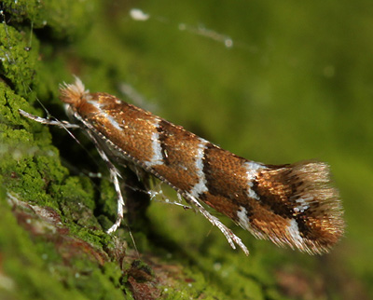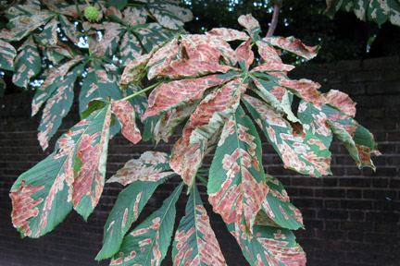

Leaf miner moth Typical effect on horse chestnut leaf

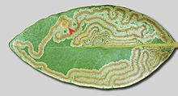

Leaf miner damage

What can you do about it? Practically, not a lot. The Forestry Commission says collect and burn any leaves and branches. Hmm. However, there are some sprays available which could be deployed to protect some fruit and vegetable infestation, but I’m afraid the trees are in for a bad time!

If you find a new attack, you are asked to contact the Forestry Commission at forestry.gov.uk

Chris Stockwell. Oct ‘16

