ROMAN EXPORTS FROM KENT THE LAST VOYAGE OF THE “FIDES”

Author’s note:
In the story which follows I have used modern place names, to assist readers in finding locations and features. Roman linear measurements, e.g. pedes and uncia, were fairly well commensurate with modern imperial measurements - feet and inches - so I have used the latter. Similarly with weights - I have used, e.g., tons and pounds. The Romans kept day time by means of dividing the period between sunrise and sunset into 12 hours. Hence, at the winter solstice the hour was shorter and at the summer solstice, longer. This story conveniently takes place around the spring equinox – the sun rose and set at about 6:00 a.m. and 6:00 p.m. respectively and the 12 hours of each day were approximately sixty minutes in length.
Brian Cushing
February 2021

LOADING
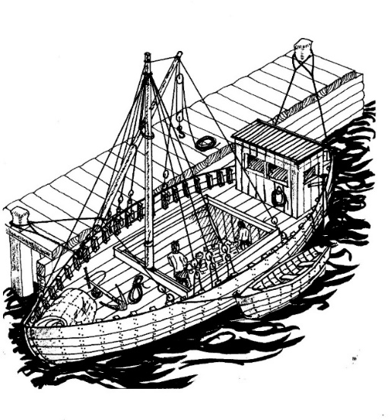
Waiting for cargo
In the year 120, Atticus Marinus, Master and part owner of the trading vessel “Fides”, stepped out of his ship’s after accommodation and on to her main deck. It was just after dawn on a clear spring morning in Roman occupied Kent. The ship was moored alongside a timber wharf, pitching gently in the river current.
Despite the early hour, the ground back of the wharf and up the steep lane to the brow of the hill, beyond which lay the stone quarries, was busy with pedestrian and vehicular traffic. Carts drawn by oxen and laden with the product that people called ragstone descended the hill, which was so steep that their progress had to be braked by tackles led from their axles to stakes driven into the verges, hauled on by forced labour.
The carts ascending the hill were, despite being empty, of substantial weight and had to be assisted by those same tackles, and shoulders to the wheels. Heavy rains had previously turned the lane into a quagmire, defeating the best repair efforts of the engineers and their crews. Now that the weather had turned clement, the mud had dried into ruts, and a haze of dust hung over the track. The labour, mostly comprising slaves – many being prisoners of war from Britain’s northern regions – and convicts, had a hard time of it to keep the traffic moving under the direction of the overseers. And there were always officers of the Imperial Navy, which operated the quarries, keeping a watchful eye and complaining and making notes when things went wrong.
Atticus had visited the stone quarries and seen with his own eyes evidence of the short and brutal life that the slaves led, subject to frequent abuse and beatings meted out by the army hard cases deployed as guards. Yet despite being of a humane disposition, Atticus, being a person of his time, regarded them with a certain indifference. They were ubiquitous in all walks of life, some treated better than others, being simultaneously the glue that kept society together and the lubricant that made the economy tick.
He leaned on the gunwale and watched the activity for a few minutes. In three or four hours, the ship ahead of his along the wharf would complete her loading and depart, at which stage “Fides” would be warped forward to take her place and commence loading, while another vessel would be berthed behind him to await her turn. It was an unrelenting, high pressure operation to satisfy the demands of the construction industry in the great city of London, some three or four days’ sailing from this place, on the border between East and West Farleigh.
He turned and looked forward. His night watchman, Luka, one of his three crewmen, all Croatian and right sailors, waved and called out that all was well. He jumped onto the wharf and walked aft to sight the ship’s after draft marks, which he himself had measured and carved into the timber of the hull. One foot four inches. He went forward and checked the marks there. Eight inches. Exactly what the drafts had been yesterday evening, which meant that no water leakages had taken place overnight. “Fides” was a sound, tight vessel, built by the Thames in the British method. He had great faith in her integrity; nevertheless, Luka would check the bilge soundings shortly. In his time at sea, Atticus had found time and again that checking and double checking always paid off.

*

At that time, the meandering and bucolic Medway Valley that we know today was a very different place. It was a dystopian, industrial landscape from which the dense forests of oak, beech and hazel had been stripped to satisfy the voracious appetites of cooking fuel to feed the thousands of workers and their overseers; of timber for the construction of wharves and warehouses along the river, and housing and stabling beyond; and of the raw stuff to produce charcoal for the iron foundries hereabouts and in the Weald.
Paved roads had been constructed from the massive stone quarries of Dean Street, Quarry Wood, and Boughton Monchelsea, to the river frontages at Tovil, Teston, East and West Farleigh and elsewhere, and the vegetation cleared back extensively from the verges to provide space for worker accommodation. The vehicular and pedestrian traffic was incessant, and while the roads mostly stood up to it, the areas between, stripped of their growth, during the winter rains became quagmires. In the hot, dry summers the whole location was shrouded in a haze of dust which stank from the unwashed bodies of thousands of men and their waste. The air was further polluted by smoke generated by cooking fires and the numerous brickworks hereabouts, and with the noxious fumes emanating from the smelting of iron in the local bloomery furnaces around Gallants Lane and beyond to Coxheath, and the tap slag and waste that they produced. There was no peace on this, the southern, side of the river; the shouts and curses of the labour and their supervisors, the lowing of the cart oxen, the metallic blows of hammers and picks in the quarries, the cracks of the lash, combined in a cacophony that never quietened entirely. At night, it seemed like a vision of hell as the valley glowed with the light of furnaces, cooking fires, and open torches by the thousand.

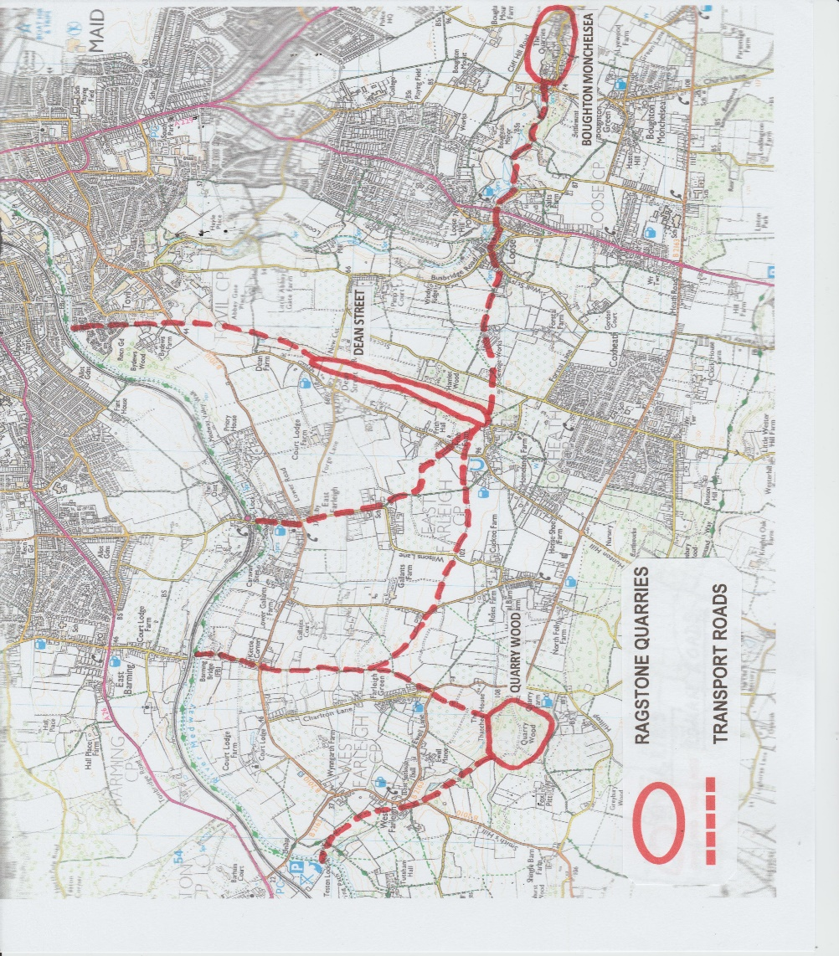

The Dean Street quarry was the mother of them all. A mile in length, viewed from the hinterland back of the Tovil riverfront it was a giant maw resembling an antheap with its thousands of workers. From each of two of the other substantial workings, Quarry Wood and Boughton, metalled roads led toward the river, converging into a single thoroughfare in Kettle Lane which continued down St Helens Lane, descending steeply to the wharves at the Farleighs. The main roads were connected and criss-crossed with side tracks and footpaths.
By contrast, the northern bank, where the government officials, industrial management and senior military personnel had their villas, temples and recreational areas, was a haven of green and pleasant tranquillity; but even here the smell and sounds of the industrial activity across the river were never wholly absent, borne over on the prevailing southwesterly winds.
The material that was being extracted from the quarries at the cost of so many injuries and fatalities, the Kentish ragstone, was a hard limestone particularly suited to building construction, being durable yet readily dressed. The most significant building effort was taking place in London, in a broad basin within whose boundary there was little outcropping of suitable stone; hence the prolific quarrying and shipping industry in and about the Medway Valley.

*

Atticus walked forward to the ship ahead of his, and chatted briefly with her Master, an old friend. Her loading would complete at about noon, the end of the sixth hour. At that point she would be towed off the wharf and “Fides” would take her place to commence cargo work.
Time enough to get a bath and breakfast. He returned on board, opened a deck locker and took out a metal trowel, a canvas bag, and an unstrung bow and a few arrows in a sheath, all of which he tossed into the ship’s tender, a two-man skiff secured alongside. He stepped into the boat, let go and fended off with one of the oars, which he fitted into a notch in the stern transom and commenced skulling upstream, calling out to Luka that he would be back within the hour. There was a spot he knew where a freshwater stream bubbled into the river. He was there in less than ten minutes, ran the skiff ashore on the shingle and made it fast with a bight around a nearby bush.
He picked up the trowel, bag, and bow and arrows, and stepped ashore. Glancing about, he stripped off: leather belt with sheathed knife and satchel attached; leather calf boots and knitted wool socks; woollen tunic and leggings, linen shirt and loincloth; red cotton bandana; all of which by habit he folded neatly on the ground. He was short and muscular, barrel-chested with close-cropped fair hair and blue-grey eyes.
He took the trowel and scraped a shallow hole in the riverbank, squatted and defecated swiftly, and backfilled the hole with earth which he trod down. He drew his knife, an eight-inch flat blade, razor sharp on both edges with a riveted wood handle, and laid it on the shingle where he could grab it quickly if need be. Taking a sponge from the bag, he stepped into the stream and washed himself from head to feet. He picked up his knife and cut a twig from the bush, which he gnawed until it was well frayed, and cleaned his teeth. Yesterday he had found wild mint growing and kept some of the leaves, which he now chewed to sweeten his breath while the breeze dried his body. He ran a hand over the stubble on his face. That could wait until they reached London in a few days, when he could take a little time off with a couple of mariner friends, get a hot bath and shave, and a square meal, and perhaps dally with the good looking ladies of Cheapside over a few cups of wine.
Whistling softly through his teeth, he dressed, and strung the bow. He picked up the arrows and made his way to the top of the bank. There were many rabbit burrows around here, and the creatures bounded around in plenty. Atticus was not a great shot with the bow, but after loosing a few arrows he had hit a couple of fat specimens. He cut their quivering throats with his knife, rinsed them in the stream and slung them in the skiff. Luka would make a tasty casserole of them later.
Gathering his belongings, he stepped back into the boat and skulled back leisurely to his ship. After he had made the skiff fast there and stowed the gear, he climbed on to the wharf, where a thin local girl was selling pasties. He bought one for a couple of small coins, and took a bite for his breakfast. It wasn’t bad; mostly grey watery vegetables. After all these years, he still missed the focaccia of his home town, baked in roaring wood ovens and topped with rich cheese and herb sauces.

*

Atticus was a Neopolitan who had learnt his trade on the shores and around the coves and inlets of the Bay of Naples and the Amalfi coast. In his early teens, even twenty or so years on from the catastrophic eruption of Vesuvius, the southeastern sector of the Bay was a wasteland on which little substantial vegetation as yet grew. Everyone knew that there were great cities, and many villages, buried under the solidified volcanic material covering the land; but exploration, even visiting, was discouraged on account of the restive spirits present. Being a man of this place, he was used to minor eruptions and earthquakes – there were tremors most months - but his family was lucky in that their property had not sustained damage.
Eschewing the family fishing business, which went back generations, after serving conscription in the Imperial Navy he had opted for a life in commercial shipping, doing time as deckhand on river and deepsea vessels, travelling extensively in the Mediterranean and through the Straits to north Africa and northern Europe, working his way up to sail as Mate and finally Master.
Throughout his seafaring career he had endeavoured to save, carrying his earnings in gold and silver coin and small treasure back to his family home when he visited from time to time. He had lost his teenage bride and their son in childbirth, and had never remarried.
When he established himself on Britain’s southeast coast, sailing as Master in the employ of a fleet owner, he looked about for an opportunity to invest in a share in a trading ship. Business in and around the area, and across the Channel in France, was buoyant and there were nice contracts to be won with the State. This period however, under the emperor Hadrian, marked a troublesome time in Britain for the occupying forces, particularly in the northern regions where rebellious natives roamed at will. Hadrian would himself visit in the year 122 and order the construction of a great wall across the neck of England between the River Tyne and the Solway Firth, in order that the rebels could be kept out and denied access to allies to the south. Later in his life, Atticus would sight sections of the unfinished wall with his own eyes, and with some awe, when on the occasional voyage to Newcastle upon Tyne, sailing upriver past Wallsend.
Five years ago, in 115, Atticus had learned from a friend with whom he was drinking in a Billingsgate wine shop that a local shipowner had fallen into debt through gambling and whoring, and now looked to sell his vessel. A few days later, Atticus met with the man and spent some hours crawling over the ship which was moored downstream of the Thames bridge, poking at her planking and frames with his knife and closely inspecting the wrought iron nails securing the two together. She was of carvel construction, built locally on the Walbrook Stream at Lothbury by the Thames five years before, and evidently staunch as there was little water in the bilges. She was sixty feet long and twenty feet wide, with a loaded draft of five feet, capable of lifting fifty tons of cargo. Her standing and running rigging, and other fixtures and fittings, were sound and well maintained. He got the owner to have his men bend the mainsail to the yard, haul it up and tension the sheets; the canvas was in good shape with little sagging. She was clearly suitable to take on the capricious weather of England’s coast, and her shallow draft was perfect for riverine navigation.
In due course he would have to get her slipped to make a thorough inspection of the underwater section; but for now he was inclined to make a reasonable offer. The owner haggled briefly but it was obvious that he was desperate to make a sale before his creditors’ thugs came calling. They settled on a figure and shook hands on it. Atticus undertook to put down a tenth of the value the next day as a deposit and provide the balance within a week. He really knew little of the seller, beyond what he had heard around the port by way of gossip. The man had the reputation of being honest; it was the lure of the gaming tables and the temptations of the flesh that had brought him down. Atticus had a bit of sympathy for his plight, having done some carousing in his youth around the pubs and brothels of Southwark and elsewhere. Nevertheless, the thought that the handshake bound him in law to the purchase, particularly if the creditors’ men might come looking for him if the man absconded, made him feel slightly apprehensive.
His employer, an entrepreneur called Philippus Viridi, was the owner of twelve trading ships who had negotiated many lucrative State contracts in shipping and other business, and who sometimes lent money at rates of interest that varied according to his whim. With his silver hair scraped back and his portly figure, he was a familiar face on the London commercial scene. He loved a deal and did not hesitate to employ bully-boy tactics to get what he wanted, but he could be outstandingly generous. He and Atticus enjoyed a mutual trust and respect, and he was inclined when in a good mood to treat him as something of a son.
These things being the case, it was naturally to Philippus that Atticus turned to source the funds that he needed. After some discussion, they agreed that Philippus would advance the necessary loan, secured on Atticus’ vouchsafing of his savings cached at the Marinus family home. They would share ownership of the vessel on an equal basis, the loan being repaid in stages from Atticus’ share of the trading profits.
There were continual outgoings and overheads to be considered. Philippus was a man who believed that you should only do business using other people’s money, hence there was interest to pay. He financed his voyages by means of bottomry loans, a kind of forerunner to modern marine underwriting, whereby lenders in London and elsewhere advanced funds to the shipowner. If the voyage was successful and profitable, the loans were repaid with interest. If ship and cargo were lost, the lenders forfeited their money. It was not unknown for certain shipowners to deliberately wreck their older, worn-out ships with the connivance of the crew, but Philippus had never been tarred with that brush and he kept many loans rolling simultaneously.
Apart from that, the ship had to be stored with victuals, equipment and spares; crew’s wages, wharfage fees and port dues had to be paid; and provision made by way of a cash float to grease certain officials’ palms. It was all part and parcel of commerce.
A week later, the ship’s erstwhile owner had received his sale money in full, and his crew had been paid off. Atticus had had his eye on a trio of Croatian freedmen, Luka, Pero and Josip, all seafarers, who were currently on the waterfront unemployed, and of whom he had heard excellent reports. He took them on and they proved their worth during the busy workup while the ship was slipped and her bottom tarred, her hull sanded and repainted, and her rigging and equipment overhauled. Her mainmast was unstepped, and it and the bowsprit boom scraped and oiled.
During this time, the ship was registered with the port of London procurator, and a lawyer engaged to check on any outstanding debts which the previous owner might have secured against her – happily, it seemed there were none.
One of the final tasks was to refit the mainmast; but before this was done, a ceremony was held by Atticus and his crew. They sacrificed a sheep on the river foreshore, and offered prayers and lighted candles to a small shrine of Neptune which they had set up in the ship’s cabin. Lastly they placed a votive coin in the mainmast step. The coin was bound to bring luck: on its reverse was an image of Fortuna, goddess of fortune, holding a ship’s rudder, and this image was placed uppermost before the mast was restored to its position and secured.
Philippus Viridi attended the ceremony too, albeit that commerce, rather than religion, was his occupational preference. Like most of his peers he was polytheistic; but some said that in his case this was more to do with covering all eventualities than true belief.
In the autumn of the year 115, “Fides” was set to sail on the maiden voyage of her new command and crew, fulfilling the first of many contracts to ship mixed cargoes to Kent, and ragstone and other goods from there to London. Atticus relished his additional role as part-owner of the ship, an ambition fulfilled not before time, as at thirty years of age he was not getting any younger.

*

Now awaiting cargo loading on the Farleighs waterfront, Atticus’ men were kept busy. The wharf was not provided with a crane, so the ship’s mainsail had to be detached from the yard and stowed, and the yard swung over the wharf, fitted with a gun tackle on the shore end and secured with guy ropes so that it could be used as a derrick to hoist loads, swing them over the hatch access and lower them down into the hold.
Throughout his shared ownership of “Fides”, Atticus had kept meticulous records of her hydrostatic behaviour, and could calculate within an inch her change of trim and bodily sinkage when laden with a given weight of cargo at any particular position in the hold. Knowing the tonnage of ragstone to be loaded, and the nature, volume and weight of the cargo that had been booked for him to load at Rochester en route to London, he had sketched a cargo stowage plan on a slate for his crew. He used charcoal to draw out a footprint of the plan full scale on the ceiling, or deck, of the hold, so that no-one could be in any doubt as to where to stow the goods.
Approaching noon on the sixth hour, activity on the ship ahead of him centred on securing its hatch covers, unrigging the cargo loading gear and bending on the mainsail, and generally preparing for departure. The towing gang that would provide the main propulsion for the ship downriver between here and Allington fronted up and made fast their towrope. Finally, with a good deal of shouting, the ship was let go and moved off the wharf. The Master turned and waved to Atticus. With luck they would meet again soon, in London or here. The ship proceeded downstream and was lost to view around the first bend.
Without delay, “Fides” was warped up the wharf by her crew to begin loading. Another vessel slipped into position behind, standing by for its turn.
Atticus stepped ashore and greeted the loading supervisor, whom he knew well – which made the exchange of documentation necessary for the carriage of the cargo that much easier. Once Atticus had loaded the ragstone, of which that designated for his ship was lying in a marked heap back of the wharf, on the issuance of a receipt he as Master became responsible for its transport and safe delivery to the consignee in London. The material would be entered on his ship’s cargo manifest, as would the goods he was booked to load from Rochester, for presentation to the domestic customs authorities.
A gang of stevedores presented on the wharf, and set about commencing loading. Two of them lowered themselves into the ship’s cargo hold to receive and stow the stones. The men were short in stature – just over five feet - and hence had ample headroom in the six feet height of the hold. The shore labour began loading the ragstone into rope cargo nets. The stone was of irregular shape and greatly differing weights – pieces varying from three to perhaps sixty or seventy pounds. The makeup of stones in each netful varied considerably therefore, and the skill of the stevedores was in assessing how much weight each load comprised. The gun tackle on the ship’s yard provided a mechanical advantage of two, so a couple of men heaving on the tackle could hoist almost a quarter of a ton – comfortably within the breaking strain of the yard and its halyard.
The first net was hoisted on the yard, swung over the hold, and lowered. From then on, loading was continuous with shifts working through day and night, the only breaks being for the consumption of food and drink, and intermittent delays consequent on transporting the stone from the quarries to replenish the heaps back of the wharf. Atticus reckoned work would be completed by noon of the day after tomorrow, all being well. The stevedores provided the grunt work, and he and his crew split watches and oversaw the stowage of the stones in the hold, according to Atticus’ plan. The stones had to be fitted carefully each against its fellows – the finished stow would be impossible to secure adequately by means of nets or ropes, and hence its integrity and resistance to shifting relied largely on the pieces interlocking.
The contract negotiated by Philippus Viridi called for the carriage over a period of time of several hundred tons of ragstone, to be shipped in a number of bottoms of which “Fides” was one. This particular shipment comprised 24 tons, plus or minus a tenth in Atticus’ option, as the Master of the ship. Knowing the tonnage of the cargoes he was booked to ship from Rochester, he reckoned he could increase that 24 tons to 26, which meant more freight payment in his, his crew’s, and Philippus’ purses.
With his knowledge of the ship’s hydrostatic characteristics, Atticus could figure accurately what bodily sinkage, as calculated by averaging the forward and after drafts, would have taken place once 26 tons of cargo was loaded, at which point he would call a halt to cargo operations.
On the morning of the day of completion of loading, Atticus spent his time continuously on the wharf or in the ship’s tender, keeping a close watch on her mean draft. For every ton of cargo loaded, “Fides” sank bodily by an inch. Her light draft being twelve inches, the loading of 26 tons of cargo would increase that to just over three feet mean. Three feet two inches to be exact, and as that draft drew close, Atticus got the stevedores to top off with small individual pieces of stone until that figure was reached. Once there he called a halt to loading, got the loading supervisor to witness the drafts, and signed off a receipt for the cargo.

*

VOYAGE

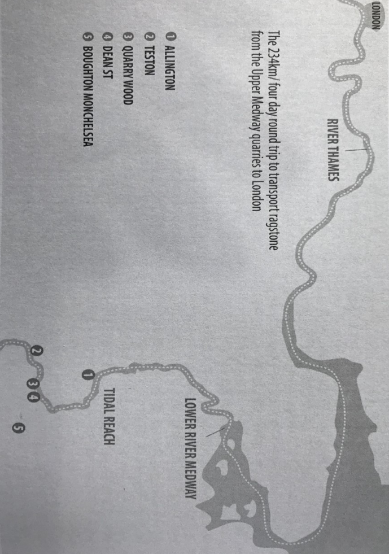
Map taken from “Ragstone to Riches” 2018 Simon Elliot
By kind permission of the author

With cargo loading completed at the Farleighs wharf, Atticus’ men set about preparing the ship for her voyage downriver to Rochester from where, after further loading, she would proceed to London. The Medway river debauched into its estuary some ten miles below Rochester at St Mary’s Island, beyond which it broadened into a wide expanse of water studded with low islands. The most hazardous section of the voyage lay beyond that, where the easternmost tip of the Isle of Grain had to be rounded in order to access the Thames estuary and the river proper to the west of that. The Thames narrowed progressively after Tilbury, and was tidal up to and a short distance beyond London.
Being a square-rigged ship, “Fides” was not efficient in beating against the wind; the most she could achieve lay about six points (around sixty degrees) off. Hence, against the prevailing southwesterlies, progress upstream in the Thames generally relied upon the flood tides, in daylight hours. Frequently, however, the wind backed to south or the east of south, and the ship could be sailed upriver. It depended in large part on Atticus’ skill in observing the weather, and in forecasting and interpreting the wind shifts.
First, however, the Medway presented its own hazards. There were two flash locks to be negotiated before Rochester: one at East Farleigh, not far downstream from where the ship had loaded; the other at Allington. There were two drawbridges to transit ; one at Tovil, the other at Rochester. Tovil also featured a low weir, with an open section in centre, deep enough to take shallow draft vessels without hindrance, but which required focussed navigation.
The two flash locks were similar in construction, built to permit navigation over differing levels where natural rapids occurred in the river. The East Farleigh lock was the first to be constructed. The initial requirement of the Roman engineers, having identified and surveyed the site, was to design, prefabricate and install the blocks of a level masonry foundation, or cill, in amongst the riverbed and rocks of the rapids. Concrete had been utilised for hundreds of years, and its propensity to set hard underwater was well known; hence it could be administered in amongst the gentler shallows to fix the cill stonework, utilising just timber shuttering. In deeper and more boisterous water, the operation was more difficult; watertight timber cofferdams had to be erected and the residual water pumped out so that the engineers and their labour could access the bed and fix the blocks.
The level and solid construction of the masonry foundation was the essential substructure, upon which a substantial timber frame was built clear across the river, excepting a narrow sluice left against the south bank. The frame was supported on its downstream side by timber baulks set into the river bed, angled at forty five degrees to it.
The object of the exercise was to stem the river so that a head of water rose upstream of the structure, and this was achieved by choking the flow with rymers – vertical timbers set against the frame – and paddles, which fit against the rymers. Once a sufficient head had built up, a section of rymers and paddles could be swiftly removed, the top beam in way slid out onto the river bank, and hence the head allowed to subside through the gap, taking ships and other waiting craft through with an adequate under-keel clearance.
This is easy enough to describe, but to prosecute it in a sixty-foot ship was a hazardous procedure. Atticus and his men were experienced and handy, but nevertheless the gap was narrow, the fast flow of water never entirely predictable, and a stray puff of wind could blow the ship off her line of entry. There was no second chance – once committed, with Atticus at one of the stern steering oars and one of his men forward with a long paddle, they were either through and clear, riding in the broken water beyond, or in trouble. They had to get clear of the lock quickly too – other vessels usually closely followed them through.
The lock-keepers at each of the Farleigh and Allington locks might have been twin brothers – they always signified their approval of a successful transit by sniffing loudly and hawking and spitting into the water. Their hard work would begin after all the craft proceeding downstream were through – then they had to oversee the upstream passage of vessels through the lock with the towing gangs against the dwindling flow, and then commence the arduous task of replacing the beam, the rymers and the paddles so that the cycle could begin over again.
On this particular day, conditions were favourable to tackle the first flash lock at East Farleigh. Visibility was good, the wind no more than a faint breeze. The towing gang brought “Fides” to a position about fifty yards above the lock, and held her close to the north bank, where a counter-current flowed upstream. She was the point vessel in a convoy of one ship of similar size, and half a dozen codicaria – smaller vessels trading locally.
The head of water was sufficient – Atticus personally sounded around his ship and found ten feet on average – so he was ready to commence the lock transit. He posted Pero forward with a long paddle secured in a rowlock over the port bow, and he himself took the starboard steering oar aft. The lock-keeper raised his arm to signal that he was about to start removing the paddles; then he and his men began the well-practiced drill of withdrawing these and the rymers, and manhandling the supporting beam on to the river bank.
The downstream current immediately increased as the head of water dissipated into the river beyond the lock. This was the crucial moment. The towing gang gave a concerted heave on the towrope, and the ship gathered headway against the counter current, which gave her some steerage way. Atticus brought her head hard round to starboard, into the fast flowing downstream current, which straightaway took her bow back to port. From now on, for the next few minutes, he and Pero would have to keep her straight and true while she shot the lock. He lined up on a tree well beyond the lock and in dead centre of the gap, and held her there. Josip let go the towrope and threw the end to the gang waiting onshore.
“Fides” passed through the gap at speed, in a welter of shouting water with just a few feet clearance on each side, and plunged into the white broken expanse beyond. Atticus and his men were soaked but pleased at a perfect operation. The lock keeper sniffed, hawked and spat.

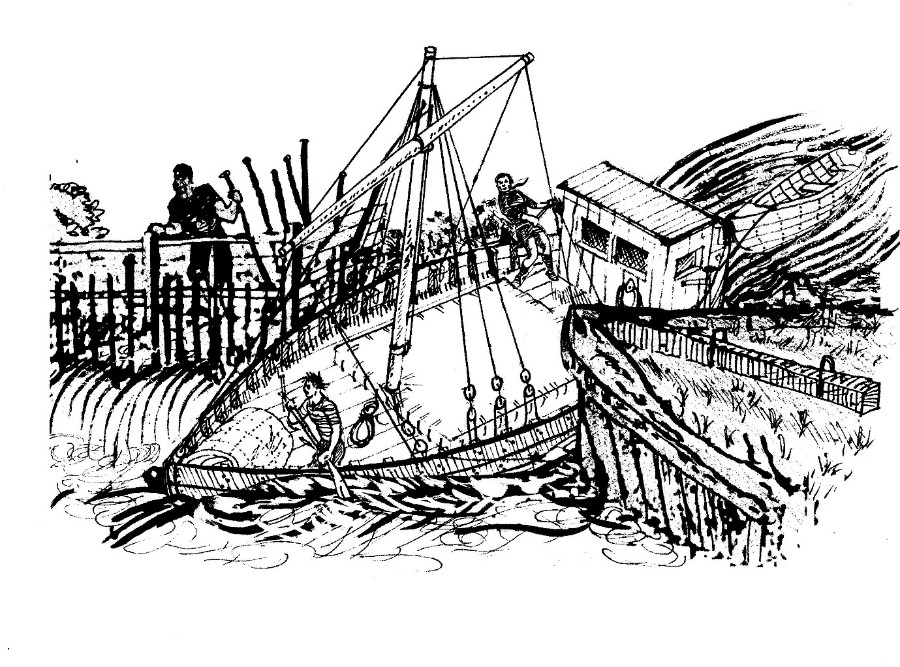
Shooting the flash lock

The towing gang threw a heaving line and reconnected the towrope. In reality, with the river current they had an easy task - towing vessels upstream against the current was a different matter. Provided his ship was kept moving with a little headway, Atticus had some steerage control and with one of his men forward with the long paddle, they could steer and keep her clear of the river banks and obstructions.
A little less than half a mile downstream from East Farleigh, the deep water channel veered over to the south side of the river – adjacent to Priory Close – and on the north bank just beyond, a timber wharf had been constructed, jutting out ten feet into the river and of some sixty feet in length. The wharf was frequently in use by vessels discharging building materials from elsewhere on the southeast coast, to service the ubiquitous construction work taking place locally. On this particular day, a ship similar in size to “Fides” lay alongside, discharging semi-finished discs of stone, some four feet in diameter and a foot thick, which were used as columnal bases.
Each of these stones, Atticus happened to know, weighed about half a ton, so their handling was a delicate process. The wharf was provided with a substantial gallows crane from which a tackle comprising four parts of rope and two double blocks was suspended, operated by manpower – three or four labourers. Each stone was individually loaded into a cargo net, hooked on and hoisted from the ship’s hold up onto the wharf, where stevedores wielding crowbars manhandled it on to a waiting cart.
As “Fides” approached this wharf from upstream, Atticus and his men were witness to a catastrophic sequence of events. The labourers were in the process of hoisting the first stone – it was most of the way up – when the tail man slipped, taking the feet out from under the next man. With half the team gone, the stone took over and plummeted vertically down into the hold, the hoisting ropes shrieking and clattering through the blocks. The ship pitched and yawed violently as the stone hit the hold ceiling and broke through the hull planking. River water fountained up, and men shouted confusedly as the ship began settling. The crew and labourers on board made a concerted scramble for the wharf ladders. Within minutes, with a full load of stone cargo, she was gone.
Atticus and his crew were silent as their ship slid past. The disaster had taken just a few minutes, and now it was difficult to believe that a vessel had existed here at all. Men stood around on the wharf, appalled. Their operation had been obliterated, and their ship, their livelihood, had vanished.

*

The transits of the weir, and of the drawbridge, at Tovil were completed successfully. The next hurdle was the flash lock at Allington, some three miles downstream, where “Fides” arrived at mid-afternoon.
This time, she was preceded by two other vessels which had been waiting. Atticus disliked not being point vessel, and to be third in the queue made the operation even more hazardous than usual, with the attendant risk of one or both of the ships ahead making a hash of it. A multiple collision in the close confines of the lock could be lethal.
He was pleased to see, however, that the lead vessel on this occasion was skippered by his friend whom he had last seen at the Farleighs a few days previously, and who had obviously taken on more cargo in the interim – probably on the wharf at Tovil. His friend’s experience told, and he and the second ship were through without incident, leaving the approach clear for Atticus. As before, he posted Pero forward with the long oar, and he himself manned the starboard steering oar.
They shot the lock immaculately. The lock keeper sniffed, hawked and spat.
Beyond Allington, the river was tidal and began broadening somewhat, so that the towing gang was redundant. Atticus paid them off from his cash float – just another overhead which had been accounted for when he and Philippus’ accountants had prepared the voyage estimate and calculated the freight rate to be charged.
From here on, wherever the ship needed assistance in negotiating the bends of the river, it would be provided by rowing boats of about cutter size, four to six oars, which were stationed below the Allington lock, touting for business. From Allington, the river flowed generally west, and beyond Aylesford trended north; so a southwesterly breeze in the sails was of assistance. There were, however, tricky passages – particularly at Burham Marshes, where the stream performed a horseshoe, bending completely back on itself - where rowing power was essential. Atticus always preferred to hire a single boat to accompany his ship right through the transit to Rochester, and he had his favourites among the waiting crews.
They were lucky on this particular day – one of his favoured rowing crews was available, and the wind stayed in the south. Low water at Allington was late afternoon, after which they managed some progress against the flood before anchoring in failing light. The next day from mid-morning, they rode the morning ebb to Rochester and were berthed in the afternoon, just before low water. The tow crew was paid off and disappeared back upriver to look for their next customer.
On berthing at the wharf by the river bridge, the superintendent in charge of cargo loading advised that on completion the following day there would be little chance of departing immediately, as the river hereabouts and the bridge would be closed to all traffic. It seemed that a substantial body of troops was scheduled to cross the river at that time.

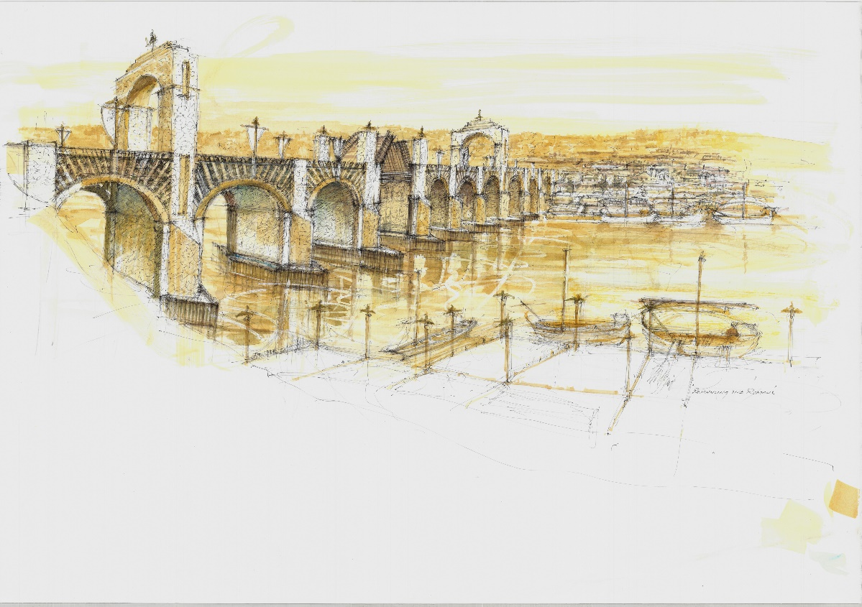
Rochester Bridge – illustration ”Romancing the Romans” by Michael Walsh, by kind permission of the artist

Loading of cargo commenced during the afternoon of arrival, in accordance with Atticus’ stowage plan. The goods consisted of crates of metal hand tools forged locally and destined for the London construction industry; bales of semi-finished sheepskins; baskets of vegetables grown here; various other general products; and a single millstone. All in all, just under 24 tons of material whose volume would block out most of the cargo hold, with the millstone rolled forward and placed in the narrow tapering section of the hold, where it would be snug; the delicate foodstuffs in an athwartship line aft of it; and the rest stowed over and around the ragstone.
During the afternoon of that first day alongside, military activity increased substantially ahead of the arrival of the expected body of troops. Cavalry vedettes, and patrols and standing sentries of infantry, were deployed around the bridge, the wharves and the streets behind. Pedestrians and wagons were stopped and searched, seemingly at random. A sentry was posted at each of the gangways of the ships on the wharf.
Atticus spoke with the loading superintendent, who seemed to know everything. “Who’s crossing tomorrow?”
“A legion from up north. Bound to Dover to embark for the Netherlands.”
Atticus grimaced. He thought of Holland as a dismally flat, marshy place, prone to frequent flooding. “Rather them than me.”
“Better than where they’ve been, brother. I’m told they took a mauling in Caledonia.”
“Which legion?” asked Atticus.
“Hispana, so I hear. The 9th.”
A passing army officer caught this final exchange, stopped and gave them a hard stare. The conversation was one they should not have been having. Atticus and the superintendent hurriedly resumed their work.
The next day, loading of cargo was almost complete. Since early morning, Atticus and his men had first heard, then sighted, the remarkable spectacle of a legion on the march. They came from the direction of London. The presence of soldiery was, this being an occupied country, commonplace and Atticus was used to it. But this was different – the first elements of scouts and cavalry seemed to number several hundred, and by the time Atticus and the crew took a closer interest, when they could spare time from their work, these and groups of mounted officers had clattered across the timber roadway and disappeared in a haze of dust to the southeast, towards Dover.
The leading groups were succeeded by centuries of infantry on foot. The bridge being relatively narrow, no more than fourteen feet wide, the columns were reduced to three or four heavily laden men abreast, interspersed with cavalry troopers who ordinarily would ride on the flanks of the column. Armour and weaponry, and the standards borne aloft, glittered in the spring sunshine. The tramp of hobnailed footwear and hooves, and the jingle of equipment and harness, coalesced into a loud rumble that echoed around the town. Each century was succeeded by its baggage train, wagons which creaked heavily across. There were other vehicles too: open carts piled high with ownerless helmets, shields and weapons; and closed medical wagons with their audible burdens of pain and misery. Many of the marching men wore wound dressings.
By late morning, Atticus, who had been keeping a rough count, estimated that less than three thousand men had transitted the bridge. In the early afternoon, the last of the infantry and the cavalry rearguard crossed. The numbers seemed well short of the five thousand or so that would be expected of a legion on the march.
A couple of hours after that, the troops securing the bridge and its approaches, and the surrounding roads and lanes, were formed up and marched off. Relative peace descended.

*

On completion of loading during the morning, Atticus’ crew set about securing the goods in the hold, lashing down to adjacent frames the bales which formed the top tier, and sawing and wedging in baulks of timber dunnage from side to side where gaps existed. Once completed, the hatch boards were fitted, and a double layer of tarpaulin stretched across and secured with wrought-iron bars and wood wedges hammered into cleats on the hatch coamings. At about midday Atticus pronounced himself satisfied with the security of the ship and cargo. The usual documentation – Master’s receipts, manifest, customs declaration – was exchanged and the ship was ready to depart, bound for London.
In the early afternoon, the superintendent hurried down the wharf with the news that the military authorities had given the all-clear for normal commerce to resume. Low water would be a couple of hours hence, so there was the tail end of the ebb tide still flowing. At least they could get clear of the wharf and well beyond the bridge before the flood set in, and anchor up for the night. There were no navigation aids such as lights or buoys to assist shipping on the river, so progress was restricted to daylight hours, usually with the tide.
Atticus and several other Masters busied their crews in a bid to be first through the drawbridge and clear. Another vessel fronted up to the bridge before “Fides”, as it was berthed somewhat nearer; but Atticus’ ship was second through and clear within an hour, sails set with a fair southwesterly breeze which would take them through the Bridge Reach and Limehouse Reach. The river was particularly serpentine at this point, but tomorrow when the ebb tide again set in at mid-morning, with a fair wind they could complete the northern passage through Chatham Reach then easterly into Gillingham Reach. After that they were in relatively open waters past St Mary’s Island, with room to manoeuvre.
On the last of the falling tide, Atticus brought his ship round to stem the ebb, and anchored in the snug elbow of the river by Chatham, close to the southern shore with the rising land affording a lee from the southwesterlies which might increase overnight. He and his men got on with their various tasks, and settled down for a late supper before turning in. There would be a watchkeeper on duty throughout the night, the shift rotated among them. Their mood was subdued – they thought of the Imperial Army as invincible, and the sight of the 9th Legion, its reduced condition and depleted numbers, had provided a dispiriting lesson.

*

The next day they were on the move before sunrise, with the sky lightening so that they could make out salient features of the river and its boundaries. The ship, with the still prevailing southwesterly wind, could with luck make the few miles toward St Mary’s Island before the full flood set in. Once past the island, where the river broadened and turned south, they anchored to await the ebb tide in the late morning.
At slack water before the commencement of the ebb, with eight miles to reach the open sea, Atticus set sail. They rode the tide along the coast of the Hoo Peninsular, making five or six knots over the ground, with main- and foresails set with the steady following wind from the southwest.
There was a waterway connecting the Medway and the Thames, Yantlet Creek, which separated the Isle of Grain from the Hoo Peninsular. It was rumoured to be navigable in the right conditions of wind and tide; and it would cut the distance to be sailed in rounding the Isle itself. Atticus had never attempted it, being wary of making passage through a narrow creek whose depths were probably variable due to silting; and he did not wish to be stranded with no assistance available in the marshy, desolate flatland of the peninsular whose inhabitants were known to be backward and hostile.
However, the mouth of the creek within an inlet of the coast was a sweet spot for lobsters and crabs, and with just a small deviation in her course, “Fides” could fetch up for an hour or so, recovering the lobster pots which Luka had laboriously manufactured out of willow, harvesting the contents and re-sewing them with fresh bait. It was something they did on all of these voyages if time and tide permitted.
By early afternoon, in a heavy swell from the northeast which had been generated by a decaying weather system in the North Sea, they shaped a course on a broad reach north and then northwest into the Thames Estuary. Josep thought it might be his birthday, although he could not be certain. In any event, they hoisted a long pennant to celebrate the event, which lifted their spirits.
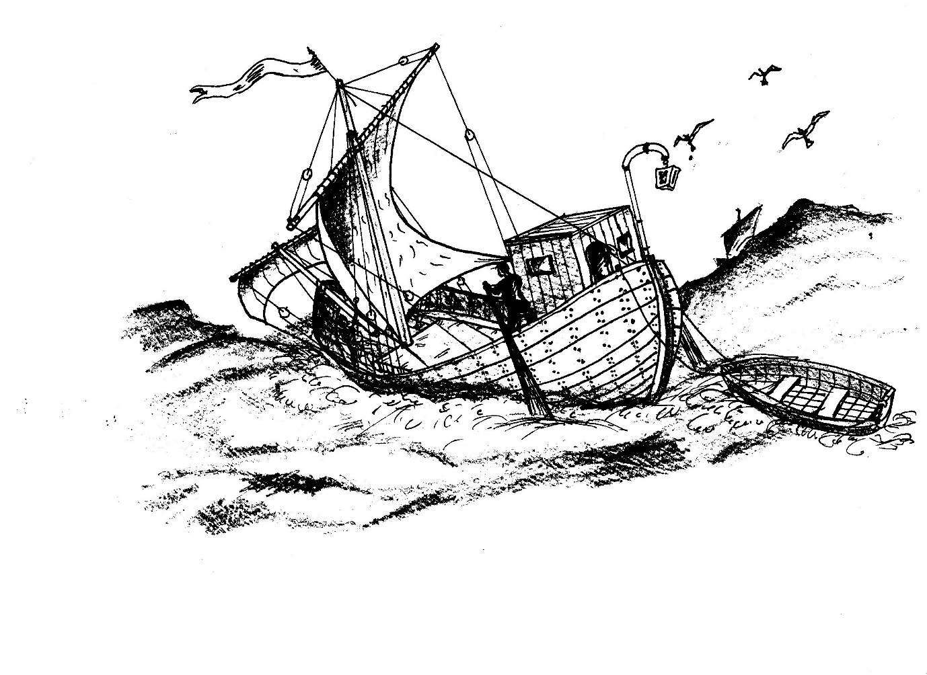
Broad reach

The ebb tide was running its final course, so now, proceeding westerly into the estuary, they could take advantage of the incipient flood and the prevailing and constant wind on the ship’s port beam.
With the light failing at the twelfth hour, in the evening, they sought a safe anchorage in the Thames River proper, and found one at a place familiar to Atticus, just past the Cliffe Pools on the south side of the river. By this time, heading as they were almost due south with the course of the river, into the wind, the sails were useless to them and they were carried along with the tide. On the morrow, they would have another thirty miles to sail to reach the Port of London – perhaps twenty hours’ sailing within the flood tides, and provided the wind stayed in the southwest to assist them.
For the time being, they were safe in their anchorage. The good progress of the voyage so far had been fortuitous, taking into account the delays beyond their control, in that they had caught the tides and the wind where those elements served them best; but Atticus’ skill in reading and interpreting those, and the experience and loyalty of his crew, had served the ship well. He never forgot that every voyage, long or short, was an adventure in the literal sense of the word.
Luka, who dealt with most of their victualling and cooking, had created a delicious bouillabaisse for their evening meal, from the lobsters and crabs they had recovered earlier, and vegetables grown in local fields which were readily available for sale in Rochester’s stalls. He patiently fed the small brick oven on its hearth aft of the accommodation with wood faggots for two or three hours, and the combination of fish, garlic, onions, leeks and fennel in wine had simmered gently, giving off teasing aromas.
Now that they had hungrily consumed the stew, mopping it up with bread, they lay around contentedly with full stomachs, gently burping. Luka was a passionate cook who always appreciated a sincere compliment, which made him an excellent mark for some ribbing.
“Luka”, said Atticus, “that stew was…” he kissed his fingertips “…almost edible”.
“Hey Luka”, said Pero, “Did you use the dishwater again when you made it?”.
“Luka”, said Josip, “That was just like my mother……never ever made.”
Luka muttered something in his guttural Croatian language, to do with going forth and multiplying, and went off to wash the pots.

*

COLLISION
The wind blew a light southerly as the ship made way into the port of London on the flood tide. With the breeze on the port beam, the main and fore sails were of help in maintaining steerage way. The wharves under and around the Thames bridge were crammed and teeming with activity, and there was clearly no chance of docking today.
Atticus steered close to the waterfront as he approached the bridge, and made out one of Philippus Viridi’s assistants waving a red cloth to attract his attention. The man shouted through cupped hands that “Fides” would in all likelihood not berth for a couple of days, due to the congestion. Atticus cursed softly – lost time meant lost money – but there was nothing for it but to continue upstream and anchor.
The ship passed under the bridge, as Pero and Josip busied themselves taking in and stowing the foresail and its boom, and hauling the big mainsail up to its yard and securing it in folds. Luka stood by forward with the heavy wrought-iron anchor balanced on the gunwale. When Atticus was happy with his position at the upstream end of the waterfront, a couple of hundred feet off so that she would not ground at low water, he came about to stem the tide and nodded to Luka to let go. The anchor sank and held swiftly on the muddy bottom, while Luka paid out cable and made it fast at four fathoms’ length. The ship came up with a nice catenary in the rope, and lay quietly with the tide gurgling along her length.
While they were at anchor, they were not idle. There was always work to do: rigging and sail canvas to check, blocks to grease, stores to audit, paintwork to repair; and the cargo to unlash and prepare for discharge. Regular duties included keeping a lookout in watches throughout the day, but particularly at night; sounding bilges; preparing meals. Luka had inevitably laid a few fishing lines overboard already, so with luck they would enjoy fresh seafood to supplement their dwindling supplies.
The evening was uneventful, the noise and lights of commerce downriver and the street sounds from the city nearby forming a backdrop. Smells, of horses, of cooking, and frequently of sewage, drifted over the ship from the waterfront.
At about midnight, a shallow cold front passed over the valley and caused a thermal inversion over the river. While Atticus did not know of the mechanics of these things, his long experience told him that the veering of the light breeze and the drop in temperature would lead to a change in the hitherto clement weather, perhaps with precipitation. Sure enough, an hour or so later a thick fog caused by the inversion descended on the water.
Of all the weather conditions that he encountered daily, fog was the one that Atticus truly hated. Although his ship was safely anchored, other craft were not and he could hear them moving about by the sounds of creaking rigging, the splash of oars and the calls of command. Conch shells on other anchored vessels soon started their mournful hooting. When standing their watches, his men kept a keen lookout, listened closely, and from time to time struck a small gong by way of warning of their position.
The night passed, but dawn brought just a fractional lightening in the murk. They could not see the foreshore, but could hear the sounds of the city waking up – the creaking of wagons and the curses of their drivers; street traders shouting their wares; calls of greeting; and the tramp and jingle of the naval patrols.
Atticus and his men had had little sleep. The tide peaked at late morning and the ship began to swing on her anchor cable to the incipient effect of the ebb. They strained their ears to identify the river sounds around. The curtains of fog shifted but did not clear.
From upstream, Atticus heard the regular beat of oars, and calls of exhortation. The shifting fog made it difficult to pinpoint the exact direction from which the sounds were coming, but he was sure they were close. He shot a glance forward – his three crew were standing in the bows, and they were staring fixedly upstream too. He was now certain that the noise was very close indeed. Josip struck the gong loudly and repeatedly.
The murk to starboard of them went pale, and then white, and then a military ship, a big white-painted bireme, burst into sight just thirty feet from them. The calls of command on it changed abruptly to shouts of alarm. The thought flashed into Atticus’ head that he was about to die. “Stop!” he shouted, uselessly. He glanced forward again and saw his men staring. The ship must have been making five or six knots over the ground on the embryonic ebb tide. Two big eyes carved into its bows stared down at him, and its forward ram created a white wash. Within seconds, it was on “Fides” and collided with a sound like a crack of thunder.
The smaller vessel rolled violently to port, and Atticus saw one of his crew catapulted overboard. The mainmast twanged and the blocks clattered loudly. He himself was flung to his hands and knees, cracking his head on the gunwale and seeing stars briefly. A confused rumble from the hold meant that her cargo had shifted. Pero, the man in the river, surfaced, cursing and spitting, and hauled himself back on board, shedding water.
A white-faced officer appeared on the forecastle of the warship and stared down. He shouted an order aft, which resulted in the worst of outcomes: oars clashed as its rowers backwatered, and with a screech of shattered timbers the warship gathered sternway, opening the hull breach wide to the river. The ship disappeared into the murk as Atticus recovered his wits and jumped over to starboard to peer overside. His ship had taken up a significant port list, due to the shift of cargo, which was her saviour for the time being as most of the ragged hole lay above the waterline. But there was still a steady ingress of water, which would get worse as she settled. Five or six frames and the adjacent planking had been taken out. Pieces of splintered wood bobbed around and floated through the gap.
Atticus forced himself to think rationally. “Pero! Josip!” he shouted. “Jump aft and man the tender! Stand by to tow her to the beach!” They ran aft, vaulted over the stern and landed in the skiff, swapping the painter to its stern and shipping the oars.
“Luka! Stand by to pay out on the anchor!” Luka waved and stooped to secure one of his precious lobster pots with its cork float to the bitter end of the anchor cable. Good man. If the cable ran out before they beached, they would stand a chance of locating the valuable anchor by the float, and recovering it later.
He reckoned the ship was more or less perpendicular to the shore. “Row like hell!” he shouted to the men in the skiff. “Fides” gathered sternway with the small boat towing.
He looked overside to starboard again. He thought she had settled about half a strake more. He had to staunch the flow of water somehow. He scrambled aft to the accommodation, jumped down the ladder to the store, and pulled from its shelf an eight foot square of canvas tarpaulin that they used as an awning in the summer. Water in the store was a foot deep, spouting in through the cargo hold bulkhead.
He groped beneath the surface and pulled out a box, in which he found a dozen iron nails, spares from those used to secure the ship’s hull planking to her frames, each one two feet long and weighing a couple of pounds. He threw these and the canvas through the hatch on to the deck, and swarmed up the ladder after them.
“Luka! Take a turn on the cable and come aft! Give me a hand, we’ve got to get this tarp overboard.”
He drew his knife, slashed a dozen holes through one edge of the tarpaulin, and threaded the nails through. Together he and Luka tied a length of cord to each of the opposite corners.
“Now – drop it overside and pull it forward over the damage.” They lowered the canvas into the water, its bottom edge freighted down with the nails. Together they pulled it forward over the breach, and made it fast. It bellied inward to the hold, but stopped some of the water ingress. Not perfect fothering, but it would have to do.
“Fides” now had considerable sternway, Pero and Josip pulling hard on the skiff’s oars. He peered overside again – she had settled another few inches. At this rate she would be lost in ten minutes or so – perhaps sooner if the mass of free surface water swilling around the hold caused a total loss of stability so that she capsized. The hatch tarpaulin bellied up as the air in the hold, compressed by the rising water, hissed through the hatch boards. He thought briefly of deploying her mainsail, still bent on to the yard. But there was little or no wind, and it would just flap uselessly and get in the way. Better to leave it stowed.
A wherry popped out of the fog to port, manned by a couple of London likely lads. They sized up the situation in an instant. One of them stood up, hefting a heaving line. “Hey mister!” he shouted. “You look like you need a hand!”
Not a chance. If they laid a line on his ship, they would claim a portion of its salved value. “We’re fine!” he roared. “Get out of here!”
They disappeared back into the fog, giving him the finger.
The sounds of the foreshore grew louder. At any time, the riverbed would shoal and the ship would ground. The skiff with its light draft could carry lines ashore. The tide was still ebbing – he thought about another two hours to low water.
Suddenly the fog cleared, like a curtain lifting. The full colour of the teeming waterfront, some hundred feet distant, was almost dazzling. People stopped to stare at their predicament. At that point, the stern grounded and stern way ceased. Pero and Josip rested on their oars. Atticus looked forward – Luka still had a turn of anchor cable on the forward mooring bitts.
As the water fell over the next couple of hours, the ship settled into the riverbed mud, still with her port list. Atticus and his men worked hard, while various of the citizenry gathered on the waterfront and offered generally useless advice. They ran mooring lines ashore with the skiff to the public bollards, and lighter lines out to port and starboard secured each to a grapnel. They deployed the bronze bilge pump to no positive effect – it was defeated by the rate of ingress of water. They got another tarpaulin overside to double the one in place over the breach, nailing it to the hull. They secured a cork float to the stem post to mark the ship’s position should she sink. It was all they could do in the limited time available before the river started flooding again, and Atticus was not confident that the canvas patch would hold – the current could run five or six knots at full flood and ebb. This was the time of spring tides too, when the rise and fall was at its maximum.
At length, slathered in mud and exhausted, they clambered up the wood ladder to the wharf. There was still work to do for Atticus. He had to organise his men into watches to stand guard over the ship, its cargo and equipment, and the skiff. He sent Pero off to an inn that he knew of nearby, to arrange accommodation, hot water and food for them. He had to find the local duty marine officer and enlist his help with security. The port captain would have to be informed of the casualty and a report made – he was sure the warship captain would by now have given his version of events to his commanding officer. He sent Luka to find Philippus Viridi or one of his assistants, with instructions to report the situation. Night was falling, but much of this had to be done straight away. He left Josip standing the first watch on the wharf, and made a start.
Much later, he returned to the waterfront. Pero was by now standing watch, and told him that, as he had feared, the river on the flood had overcome their temporary patching and after floating briefly, the ship had sunk. The stern lines secured to the public bollards stretched out into the river, and he could make out her mast and rigging, and the cork buoy which they had left secured forward, which told him that she was still orientated at right angles to the shore. Tomorrow, in daylight, he could assess the situation and make a plan to salvage her, or failing that to get some or all of the cargo discharged and carry ashore whatever stores and equipment they could save. He checked that Pero had got some hot food and drink at the inn, and left him to it with instructions to call him at any time if need be.

*

The mist was thickening again as Atticus made his way along the wharf toward the lodgings where he anticipated a wash with hot water, and something to eat. He was depressed, dog-tired and filthy. Torches flickered at intervals along the way. Two figures emerged from the gloom – the boatmen he had encountered earlier when “Fides” was under tow to the beach. They stopped and stared at him.
“Well lookee here. It’s the Roman pimp, come to hand his purse over” said one proleptically. He produced a knife, and his companion sniggered.
It had been a long day for Atticus, and he didn’t think twice. He clenched his fist, stepped forward, and dealt the man a mighty blow on his sternum, over the heart. The man dropped his knife with a clatter and staggered back, falling heavily onto his backside. He seemed to have trouble breathing. Atticus now drew his own knife and levelled it at the other, watching him attentively. The man’s eyes flickered between Atticus and his mate on the ground, and he abruptly turned and ran for it.
Atticus kicked the dropped knife over the wharf edge into the river, where it landed with a plop. The man had recovered some of his breath and was inhaling with whooping gasps.
“Hey” said Atticus. The man raised his face but avoided Atticus’ gaze. “There’ll be a file of marines patrolling here in a minute. They don’t take kindly to Roman citizens being robbed, so make yourself scarce or you’ll be bound for the stone quarries.”
The man raised himself onto his hands and knees, and with evident difficulty onto his feet. Clutching his chest, he stumbled off and disappeared into the night. Atticus sheathed his knife and massaged his knuckles, which now pained him, and continued his journey to the inn. Perhaps he should not have let the man go, but he could not be bothered with the prospect of an arrest, attendance at the marines’ station, making a witness statement and all the rest of the formal rigmarole. He just wanted to get clean and eat.

*

The next morning, Atticus and his men were up and about before dawn and made their way to the wharf, where Luka was standing watch. It was about an hour after low water and the tide was beginning to flood. “Fides” presented a sad sight – listed heavily to port in the glutinous riverbed mud, the canvas patch to starboard tattered, water dribbling from the breach in her hull. It was clear straightaway that she could not be salved.

EPILOGUE

Over the ensuing weeks and months, Atticus and his crew, together with hired help, salvaged what they could of their ship’s fittings – mast, sails, foresail boom, blocks, anchor, those stores which had not perished in the water such as sealed amphorae of wine and oil – and her cargo. The baskets of vegetables were ruined, but they were able to save the sheepskins, metal hand tools and other various small items. The ragstone defeated their efforts in the limited times that the ship was high and dry, as did the heavy millstone at its cramped forward stowage. The stone was of low intrinsic value, and to persevere after a certain point became pointless with the labourers’ wages, and other expenses, to pay.
He and Philippus Viridi did extended battle with the voyage financiers, who took the line that the collision was Atticus’ fault since he shouldn’t have been anchored where he had, and therefore that they deserved their money back. This reasoning was not helped by the military bireme captain’s report, in which he naturally absolved himself of blame using the same logic.
Months on, the dispute ground through a commercial arbitration, whose finding was that Atticus had acted correctly and that the military ship was wholly at fault. This award was binding and enforceable in Court, so there was not much that the Navy could do about it, and the financiers lost their money – which was later put to good use in purchasing another, similar, vessel and in retaining the services of Luka, Pero and Josip in the interim.

*

In 1962, nearly two millenia later, during the construction by Blackfriars Bridge of a gantry to serve a cofferdam for use in the building of a new river wall, the contractors turned up ship’s timbers. Further extensive investigations on site by teams led by Peter Marsden later that year revealed the remains of the vessel which became known as the “Blackfriars Ship”. The ship was orientated at right angles to the shore, heavily listed to port, and had sustained extensive damage to her starboard side. The remains of cargo was found within the hull: ragstone subsequently sourced to the Medway Valley, and a single millstone originating from the Folkestone area. The vessel was sixty feet in length and twenty feet beam.
Most intriguingly, the mast step was intact, and within it was found a votive coin, with an image of Fortuna, goddess of fortune, holding a ship’s rudder, placed uppermost.

**************************************************

Further reading…
“Ragstone to Riches” BAR British Series 638 2018 Simon Elliot
“Sea Eagles of Empire: The Classis Britannica and the Battles for Britain” The History Press 2016 Simon Elliot
“Ships of the Port of London” English Heritage 1994 Peter Marsden
“Notes on the early technical development of European canal locks” 2011 Mike Clarke
“The Iron Industry of the Weald” 1985 Henry Cleere & David Crossley
“The building stones of South East England; mineralogy and provenance” British Geological Survey Graham Lott and Don Cameron
“Strategic stone study: A building stone atlas of Kent” English Heritage 2011 Gallagher Group
“The Roman bridge in masonry” Kent Archaeological Society 2017 John J Robson (1921)

Almost two thousand years later, in 2014, an Environment Agency craft was dredging this section of river and turned up some of the circular stones. The find was reported to local archaeologist Dr Simon Elliot, who recorded them and subsequently arranged for Royal Engineer divers to explore the site. More of the stones were found, together with ship’s timbers and several piles driven into the river bed – the remains of the wharf. Three of the stones can be seen on the riverbank adjacent to East Farleigh bridge, where they were brought by the dredger.

